ADA Kick off meeting in Novi Sad

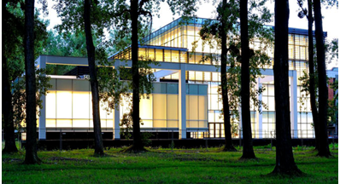
General Information

Location: University of Novi Sad, Dr Zorana Đinđića 1, Novi Sad
Room: Conference room, 1st floor
Date: November 26-27, 2018
Agenda: TBA

Airport Transfer

The city itself doesn't have an airport and the closest one is Nikola Tesla International Airport (80 km from Novi Sad). Other possible airports in wider area are

- Timisoara, Romania (154 km)
- Budapest, Hungary (295 km)
- Zagreb, Croatia (370 km)

Taxi companies run everyday transportation from airports in the region (Belgrade, Budapest, Timisoara, and Zagreb) to Novi Sad and back. We suggest the following companies:

1. AUTOTURIST http://www.autoturist-ns.com/en/airport-transfer/

2. KIKI http://www.kiki021.com/index.php/

You can book the transportation online. The price per vehicle and per way from Nikola Tesla airport to Novi Sad is around 35 €. The price per vehicle and per way from Budapest airport to Novi Sad is around 140 €.

Another possibility to get to Novi Sad from Nikola Tesla airport is to take bus (the price is about 2 €) or taxi (about 15€) from the airport Nikola Tesla to Belgrade – Railway/Bus station and then to take bus to Novi Sad (1.5 hours trip – price is about 7€). Buses on relation Belgrade-Novi Sad-Belgrade runs every 15 min during peak hours, every 30 min during the rest of the working day and every 1 hour during late evening hours until midnight.

Transportation in Novi Sad

- GSP public: one ticket price is 0.5€

- Taxi: you will be able to reach all major city destinations under 3€ per direction regardless of the number of people in the car

VIP taxi +381-21-444000 | Red taxi +381-21-525150 | Delta taxi +381-21-553333
Naš taxi +381-21-6300300 | Lux taxi +381-21-6300000 | Pan taxi +381-21-455555

Accommodation

There is a wide range of hotels in Novi Sad. Please find bellow some of them.

Hotels | Single room (€) | Distance from the University
Voyager, B&B  http://www.voyagerns.co.rs/index.html/ | 40 | Walk 5 min
Hotel Centar  https://hotel-centar.rs/ | 60 | Walk 15-20 min
Hotel Putnik  http://www.hotelputnik.rs/ | 36 | Walk 15-20 min
Veliki, B&B  http://www.hotelvelikinovisad.com/ | 35 | Walk 15-20 min
Hotel Mediteraneo  http://hotelmediteraneo.rs/ | 40 | Walk 15-20 min
Official currency in Serbia is the Dinar (RSD).
Coins: 1, 2, 5, 10 and 20 Dinars, Banknotes: 10, 20, 50, 100, 200, 1000 and 5000 Dinars. There are numerous exchange offices across Novi Sad.

1€≈ 118.25RSD

About Novi Sad

Novi Sad is the capital of The Autonomous Province of Vojvodina and the second largest city in Serbia. It is the industrial, cultural, scientific, educational, and administrative centre of Vojvodina.

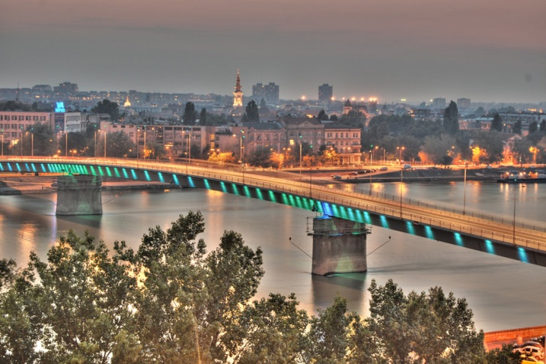
Novi Sad has a population of about 300,000 inhabitants and highly developed economic and cultural activities. The first Grammar School was founded in 1810. The first professional theatre – The Serbian National Theatre was founded 1861, and the oldest cultural distribution among the Serbs – the Matica Srpska moved from Budapest to Novi Sad in 1864. What is now known as The Serbian Academy of Arts and Sciences – Novi Sad branch was the Academy of Arts and Sciences of Vojvodina founded in 1979.
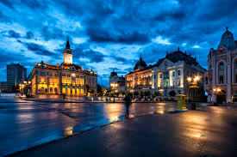
Novi Sad offers a wide range of interesting sights and is famous for its Petrovaradin fortress and attractive resorts outside the town on the river Danube, in Fruška Gora, the hills near Novi Sad, as well as for its fishing and hunting. For further information, please see http://novisad.travel/en/

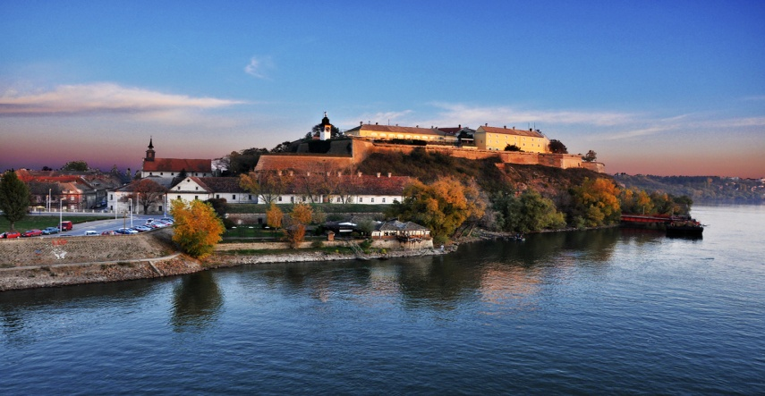

We are looking forward to seeing you soon in Novi Sad!

